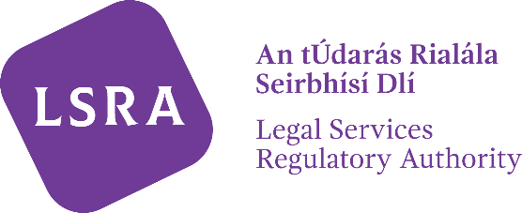
LSRA Reference Number:
PB
Amendment to Details on the Roll of Practising Barristers
Change to Information Displayed on the Roll of Practising Barristers

Description | Previous Details | New Details
First name

Surname

Other Professional Name

Member of the Law Library | YES/NO | YES/NO
In full-time service of the State | YES/NO | YES/NO

Please use the following Correspondence address(es) to contact me
and remove any others from the LSRA records

Please use the following Email address(es) to contact me
and remove any others from the LSRA records

Please use the following Phone number(s) to contact me
and remove any others from the LSRA records

Signature ________________________________ Date
Name in Block Capitals:

ALL COMPLETED AMENDMENT FORMS SHOULD BE SUBMITTED BY EMAIL TO lsra-roll@lsra.ie OR BY POST TO THE LEGAL SERVICES REGULATORY AUTHORITY, PO BOX 12906, DUBLIN 7

