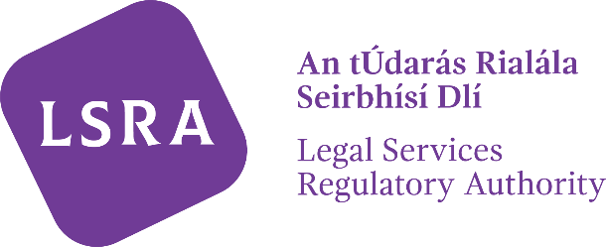
LSRA Reference Number:
PB

APPLICATION FOR REMOVAL FROM THE ROLL OF PRACTISING BARRISTERS UNDER SECTION 135(3) OF THE LEGAL SERVICES REGULATION ACT 2015

Section 1 - Request for removal

I (name in block capitals) no longer wish to provide legal services as a practising barrister and hereby apply to have my name removed from the Roll of Practising Barristers.

Section 2 - Contact Details (If different from those previously provided)

Email:

Phone:

Postal Address:

Signature ________________________________ Date:
Name in Block Capitals:
PB: __________________
NOTE: The completed form can be returned by email to Lsra-roll@Lsra.ie or by post to Registration, Levy and Fees Unit, Legal Services Regulatory Authority, PO Box 12906, Dublin 7

